

**《数据库原理及应用**

**课程设计》**

**题目：学生选课系统**

**系 别： 计算机信息与技术系**

**专 业： 软件工程**

**班 级： B140604**

**姓 名： 范 卓**

**学 号： B14060405**

**指导教师 ： 高 峰**

×××2017年01月

目 录

1.需求分析 2

1.1 问题描述 2

1.2 需求分析 2

1.3 开发环境 2

2.概要设计 3

2.1在线选课系统用例图 3

2.2在线选课系统页面交换图 3

2.3在线选课E-R图 4

2.6在线选课实体图 4

3.数据库设计 5

4.详细设计 9

总结 13

参考文献 14

源程序清单 15

# 1.需求分析

## 1.1 问题描述

随着社会的发展，人类科技文明的进步，企业彼此间的竞争日趋激烈，信息管理技术在企业的发展中占据着越来越重要的地位。“学生选课系统”可以是面向企业或事业单位的科学、全面、高效进行人事管理的系统，可以根据企业或事业单位人事管理的实际情况，进行科学的、具体的、实用性的系统设计。内容包括机构的建立和维护，人员信息的录入和输出，各种实用信息的浏览，学生登陆选课、查看已选课程；教师登陆添加课程、查看所有课程等功能。系统简便灵活实用，自动化功能较强。

## 1.2 需求分析

1. 建立相应的数据库存储信息

2. 学生登录端

3. 学生选课界面

4. 学生查看已选课程

5. 教师登录端

6. 教师查看所有课程

7. 教师添加课程信息

## 1.3 开发环境

该选课系统用开发语言为JavaWeb，存储数据采用MySql数据库实现存储，界面显示及优化应用jsp+javascript+css开发，而后台处理功能则是运用java语言编写，开发软件为eclipse，用Tomcat服务器+Google浏览器运行。

# 2.概要设计

## 2.1在线选课系统用例图

**如图1**

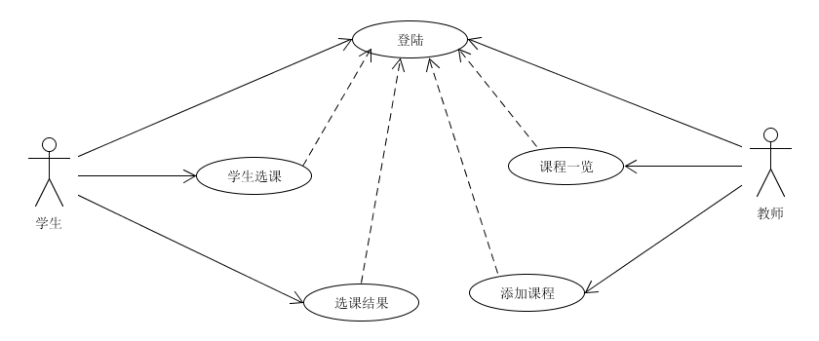

图1

## 2.2在线选课系统页面交换图

**如图2**

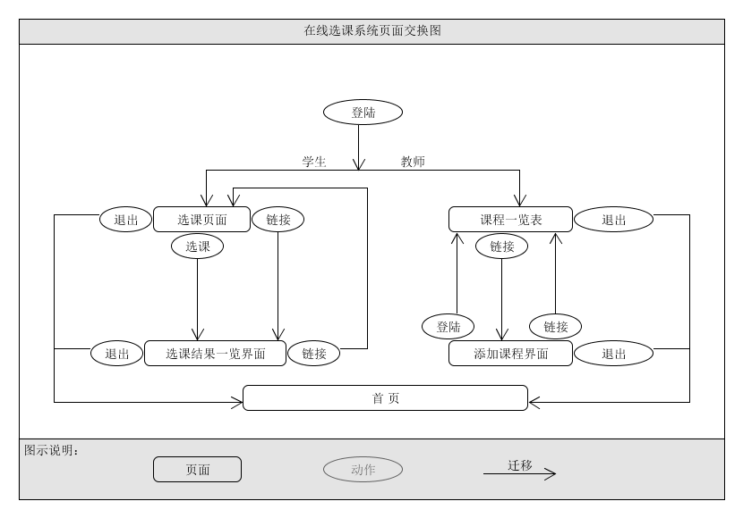

图2

## 2.3在线选课E-R图

N个学生选择M门课程（如图2.3.1） N个教师可以添加M门课程（如图2.3.2）

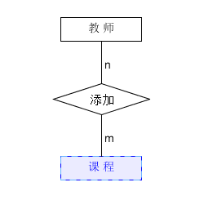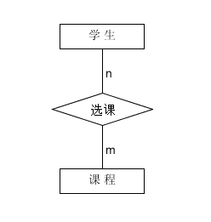

图2.3.1 图2.3.2

## 2.6在线选课实体图

用户（学生、教师实体图）（如图2.6.1）

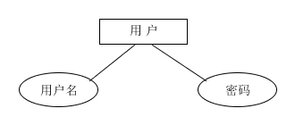

图2.6.1

课程实体图（如图2.6.2）

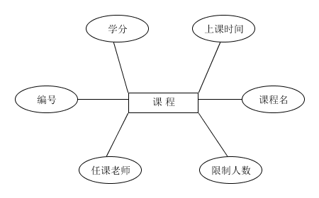

图2.6.2

# 3.数据库设计

数据库设计：（MySql）

######创建course表######

## course表为教师添加课程以及教师、学生查看课程相关信息表。表中设有字段名course_id表示课程号；course_name表示课程名；teacher表示教师名；point表示学分；time_1表示第一次上课时间；time_2表示第二次上课时间；limited表示最大限制人数。 （如图3.1、图3.11） ##

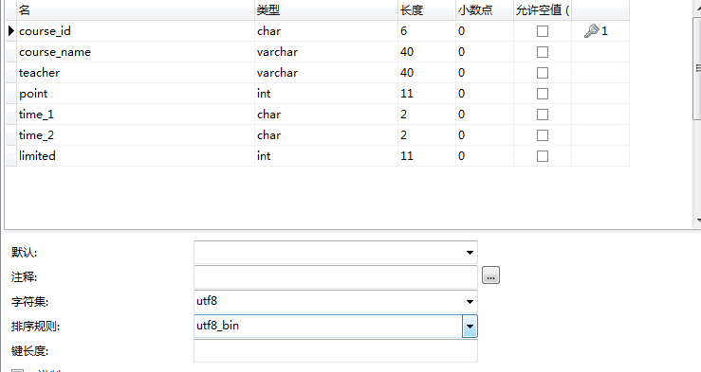

图3.1



图3.11

-- ----------------------------

-- Table structure for `course`

-- ----------------------------

DROP TABLE IF EXISTS `course`;

CREATE TABLE `course` (

`course_id` char(6) CHARACTER SET utf8 COLLATE utf8_bin NOT NULL ,

`course_name` varchar(40) CHARACTER SET utf8 COLLATE utf8_general_ci NOT NULL ,

`teacher` varchar(40) CHARACTER SET utf8 COLLATE utf8_general_ci NOT NULL ,

`point` int(11) NOT NULL ,

`time_1` char(2) CHARACTER SET utf8 COLLATE utf8_general_ci NOT NULL ,

`time_2` char(2) CHARACTER SET utf8 COLLATE utf8_general_ci NOT NULL ,

`limited` int(11) NOT NULL ,

PRIMARY KEY (`course_id`)

)

ENGINE=InnoDB

DEFAULT CHARACTER SET=utf8 COLLATE=utf8_general_ci;

######创建elective表（如图3.2、图3.22）######

######elective表表示学生选课表，记录所有学生名和课程编号######

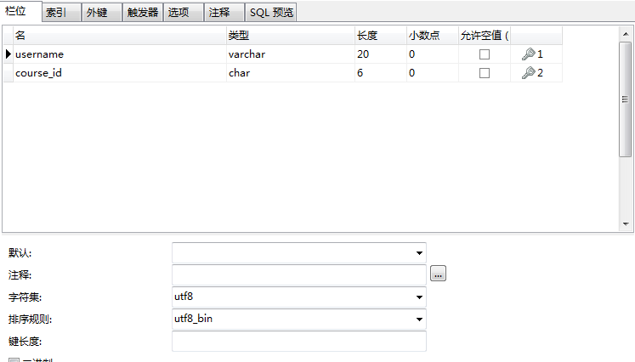

图3.2

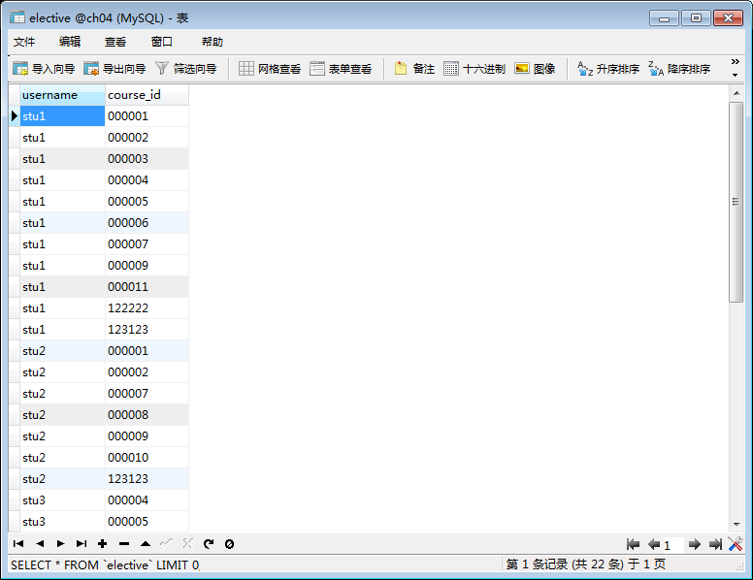

图3.22

-- ----------------------------

-- Table structure for `elective`

-- ----------------------------

DROP TABLE IF EXISTS `elective`;

CREATE TABLE `elective` (

`username` varchar(20) CHARACTER SET utf8 COLLATE utf8_bin NOT NULL ,

`course_id` char(6) CHARACTER SET utf8 COLLATE utf8_general_ci NOT NULL ,

PRIMARY KEY (`username`, `course_id`)

)

ENGINE=InnoDB

DEFAULT CHARACTER SET=utf8 COLLATE=utf8_general_ci;

######创建user表######

#### user表主要功能是学生和教师的用户名和密码username表示用户名；password表示密码；relname为真实姓名；role表示登录类别，role为0学生登录，role为1教师登陆。（如图3.3、图3.33） ####

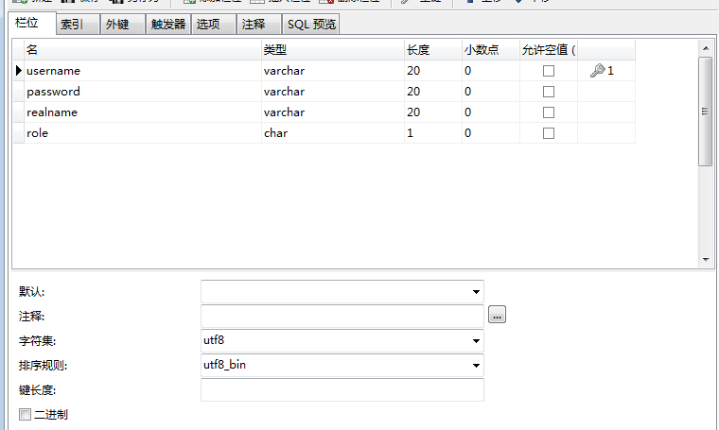

图3.3

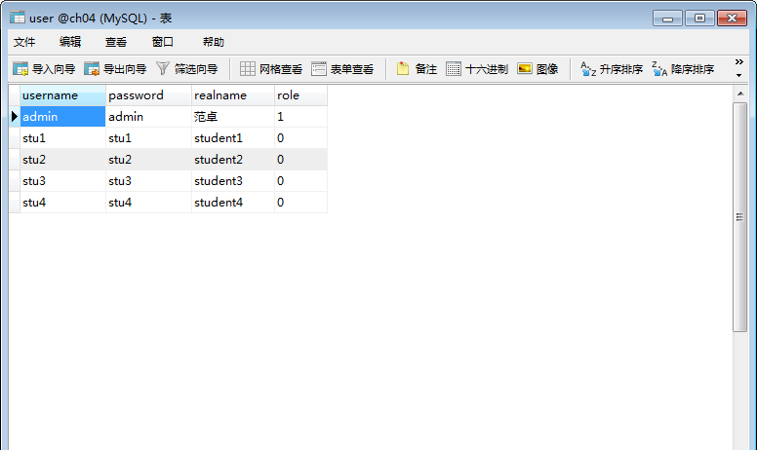

图3.33

-- ----------------------------

-- Table structure for `user`

-- ----------------------------

DROP TABLE IF EXISTS `user`;

CREATE TABLE `user` (

`username` varchar(20) CHARACTER SET utf8 COLLATE utf8_bin NOT NULL ,

`password` varchar(20) CHARACTER SET utf8 COLLATE utf8_general_ci NOT NULL ,

`realname` varchar(20) CHARACTER SET utf8 COLLATE utf8_general_ci NOT NULL ,

`role` char(1) CHARACTER SET utf8 COLLATE utf8_general_ci NOT NULL ,

PRIMARY KEY (`username`)

)

ENGINE=InnoDB

DEFAULT CHARACTER SET=utf8 COLLATE=utf8_general_ci;

# 4.详细设计

学生登陆界面（如图4.1）

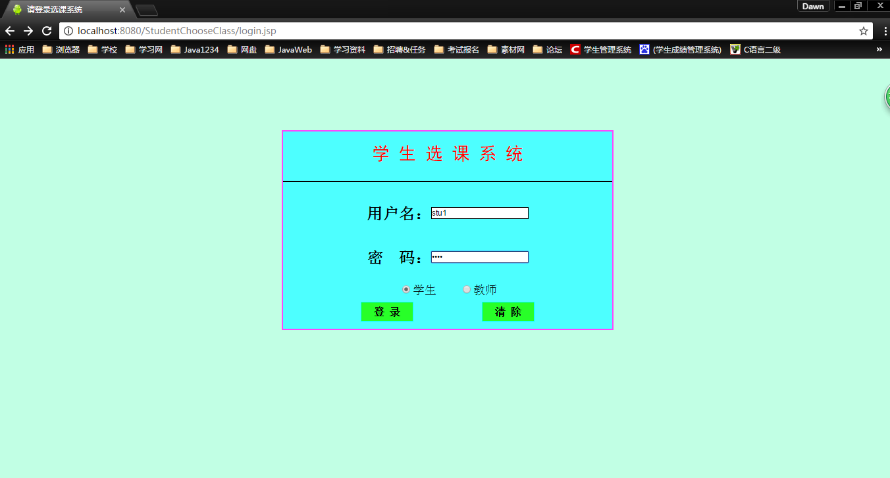

图4.1

学生在线选课界面（如图4.2）

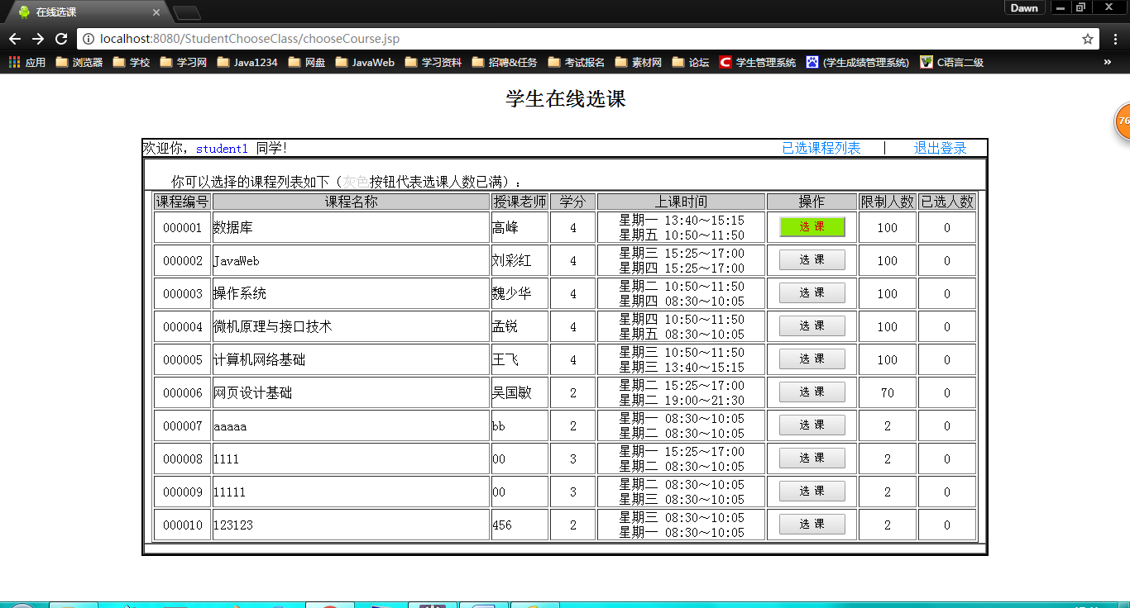

图4.2

选课成功界面（可查询选课类别）（如图4.3）

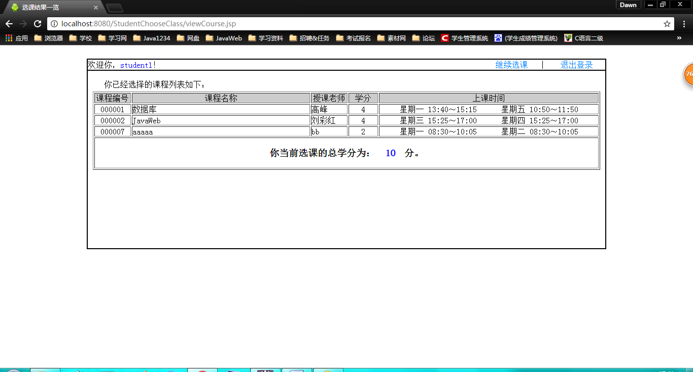

图4.3

课程人员已经满员，按钮变暗，不可再选！

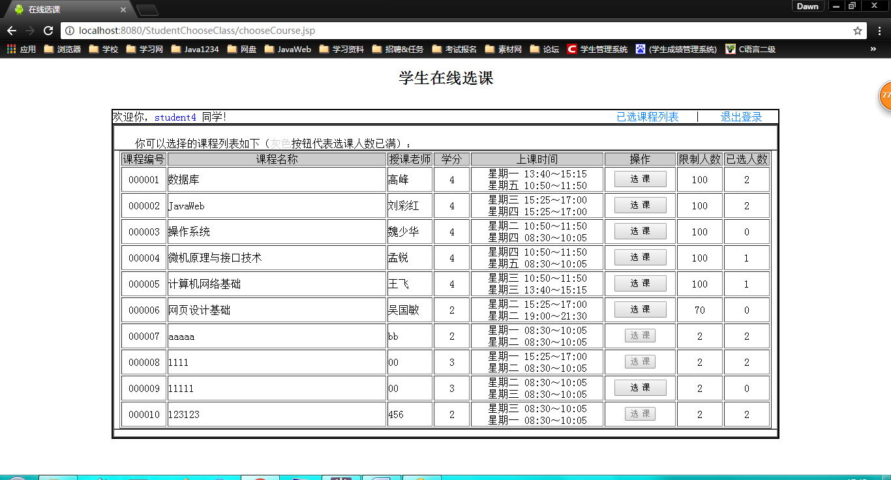

图4.4

教师登陆界面（如图4.5）

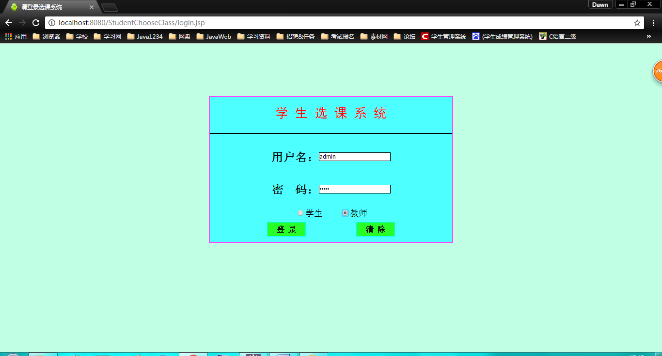

图4.5

课程总览界面（如图4.6）

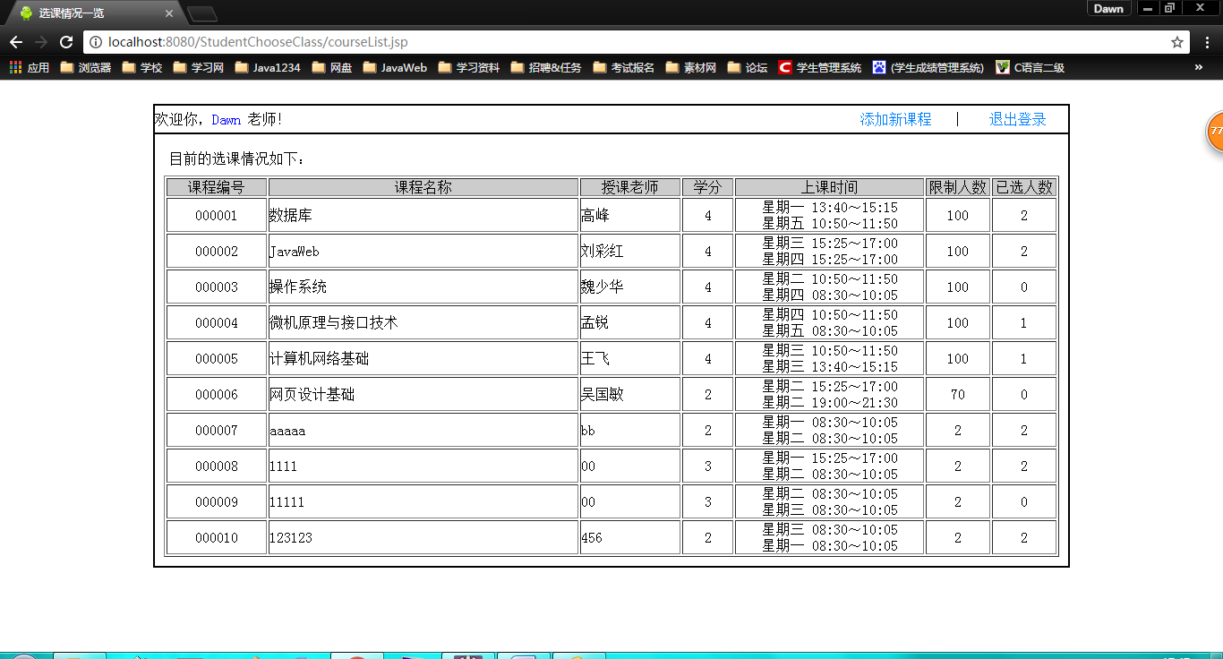

图4.6

添加课程界面（如图4.7）

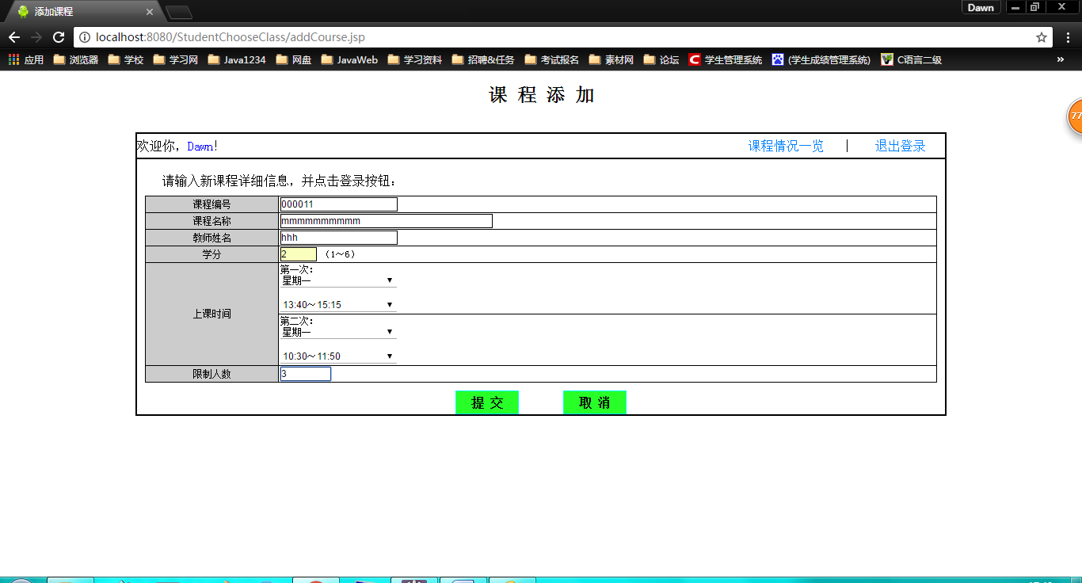

图4.7

添加成功界面（如图4.8）

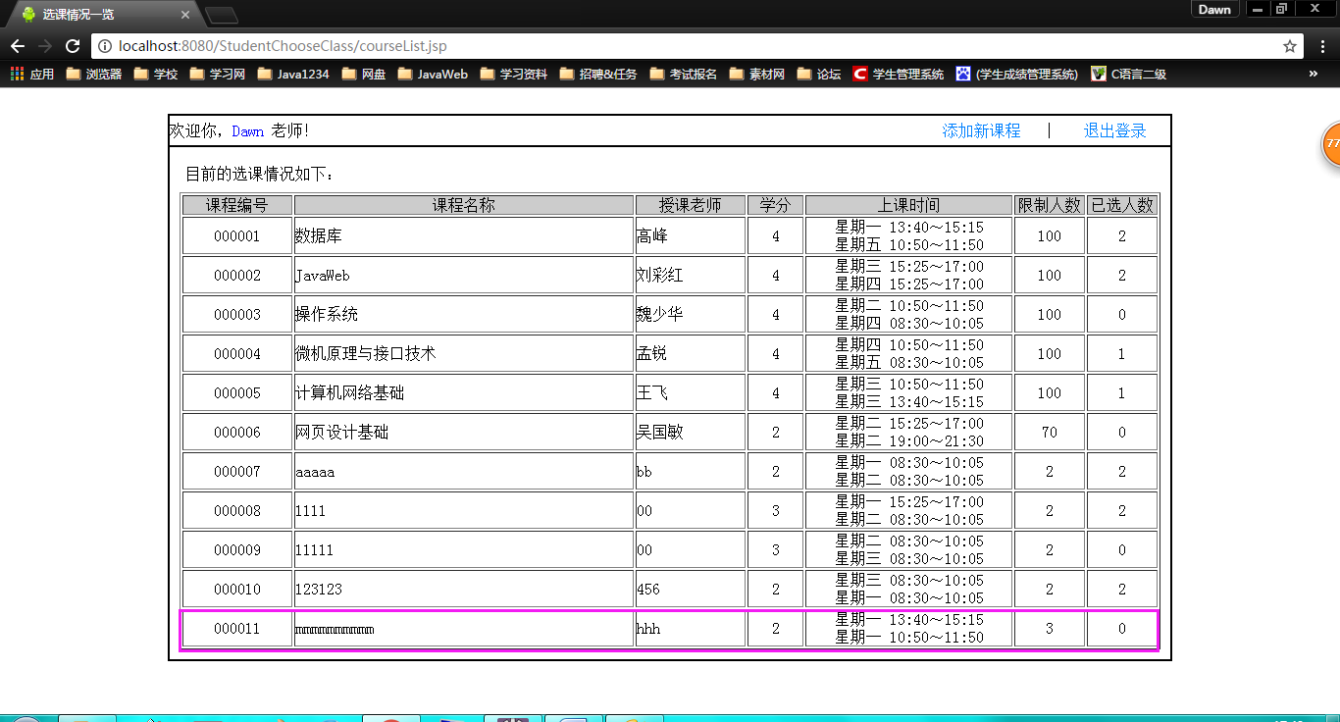

图4.8

# 总结

通过这次的系统设计，我在很多方面都有所提高。综合运用所学知识的理论知识实际训练从而培养和提高了独立工作的能力，巩固所学的知识，掌握系统程序的编排和运行，使自己的独立思考能力有了显著提高。

从各种文档的阅读到开始的需求分析、概念结构设计、逻辑结构设计、物理结构设计。亲身体验了一回系统的设计开发过程。很多东西书上写的很清楚，貌似看着也很简单，思路非常清晰。但真正需要自己想办法去设计一个系统的时候才发现其中的难度。经常做到后面突然就发现自己一开始的设计有问题，然后又回去翻工，在各种反复中不断完善自己的想法。

在设计过程中，体现出了自己的平时所积累的知识重要。综合运用所学的知识，真正体会到学以致用，突出自己劳动成果的喜悦心情，从中也发现了自己的不足和薄弱环节，从而进行弥补和学习。在这次设计过程中我的收获非常大！

通过这次课程设计发现这其中需要的很多知识我们没有接触过，去图书馆查资料的时候发现我们前边所学到的仅仅是皮毛，还有很多需要我们掌握的东西我们根本不知道。同时也发现有很多已经学过的东西我们没有理解到位，不能灵活运用于实际，不能很好的用来解决问题，这就需要我们不断的大量的实践，通过不断的自学，不断地发现问题，思考问题，进而解决问题。在这个过程中我们将深刻理解所学知识，同时也可以学到不少很实用的东西。

# 参考文献

[1] 王珊、萨师煊. 《数据库系统概论》第五版. 高等教育出版社

[2] 刘凤玲.WEB 应用技术[T].北京：清华大学出版社

[3] 石志国.JSP 应用教程.北京：清华大学出版社

[4] 陈雪莲.网络与 Web 技术导论[T].北京：清华大学出版社

[5] 闻力欧.网页制作实用教程[T].北京：清华大学出版设

[6] 相万让主编．网页设计与制作．人民邮电出版社

[7] 张桂珠.Java 面向对象程序设计[T].第三版.北京.清华大学出版社

# 源程序清单

//登陆界面（学生登陆，老师登陆）login.jsp

<%@ page language=*"java"* contentType=*"text/html; charset=utf-8"*

pageEncoding=*"utf-8"*%>

<!DOCTYPE html PUBLIC "-//W3C//DTD HTML 4.01 Transitional//EN" "http://www.w3.org/TR/html4/loose.dtd">

<%@page language=*"java"* import=*"java.util.*"* %>

<%@page language=*"java"* import=*"ch04.*"* %>

<%

String sUsername = (String)session.getAttribute("username");

**if** ( sUsername == **null** )

{

sUsername = "";

}

String sRole = (String)session.getAttribute("role");

**if** ( sRole == **null** )

{

sRole = "0";

}

%>

<html>

<head>

<meta http-equiv=*"Content-Type"* content=*"text/html; charset=utf-8"*>

<title>请登录选课系统</title>

<script language=*"JAVASCRIPT"* src=*"common/cmnScript.js"*></script>

<script language=*"JAVASCRIPT"* src=*"login.js"*></script>

<link rel=*"stylesheet"* type=*"text/css"* href=*"common\cmnStyle.css"* TITLE=*"common"*></link>

<script language=*"JAVASCRIPT"*>

<%

**if** ( session.getAttribute("errMsg") != **null** )

{

%>

**var** sErrMsg = "<%=session.getAttribute("errMsg")%>";

<%

}

**else**

{

%>

**var** sErrMsg = "";

<%

}

%>

</script>

</head>

<body bgcolor=*"#C1FFE4"*>

<table border=*0* cellpadding=*0* cellspacing=*0* height=*100*>

<tr>

<td>

&nbsp;

</td>

</tr>

</table>

<form name=*"form_main"* action=*"servlet/Login"* method=*"post"*

onsubmit="return checkInput();" onreset=*"resetForm()"*>

<table border=*0* cellpadding=*0* cellspacing=*2* bgcolor=*"#FF44FF"* align=*center*>

<tr>

<td>

<table border=*0* cellpadding=*0* cellspacing=*0* bgcolor=*"#4DFFFF"* width=*500* height=*"300"*>

<tr>

<td>

<br><center><font face=*"黑体"* color=*"red"* size=*"16"*> 学 生 选 课 系 统 </font></center><br/><hr color=*"#000000"*>

</td>

</tr>

<tr>

<td height=*5*></td>

</tr>

<tr>

<td align=*center*>

<table border=*0* cellpadding=*0* cellspacing=*0* bgcolor=*"#4DFFFF"*>

<tr>

<td align=*right*><h2>用户名：</h2></td>

<td>

<input type=*"text"* name=*"username"* length=*10* maxlength=*20* value=*"*<%=sUsername%>*"*></input>

</td>

</tr>

<tr>

<td align=*right*><h2>密&nbsp;码：</h2></td>

<td>

<input type=*"password"* name=*"password"* length=*10* maxlength=*20*></input>

</td>

</tr>

</table>

</td>

</tr>

<tr>

<td height=*5*></td>

</tr>

<tr>

<td align=*center*>

<input type=*"radio"* name=*"role"* value=*"0"* style="border-width: *0px*;"

<%

**if**( sRole.equals("0") )

{

%>

checked

<%

}

%>

><font size=*"6"*>学生 &nbsp;</font>

<input type=*"radio"* name=*"role"* value=*"1"* style="border-width: *0px*;"

<%

**if**( sRole.equals("1") )

{

%>

checked

<%

}

%>

><font size=*"6"*>教师</font>

</td>

</tr>

<tr>

<td height=*5*></td>

</tr>

<tr>

<td align=*center*>

<input type=*"submit"* value=*"登 录"* class=*"button0"*> &nbsp; &nbsp; &nbsp; &nbsp;

<input type=*"reset"* value=*"清 除"* class=*"button0"*>

</td>

</tr>

<tr>

<td height=*10*></td>

</tr>

</table>

</td>

</tr>

</table>

</form>

</body>

</html>

//学生选课界面chooseCourse.jsp

<%@ page language=*"java"* contentType=*"text/html; charset=utf-8"*

pageEncoding=*"utf-8"*%>

<!DOCTYPE html PUBLIC "-//W3C//DTD HTML 4.01 Transitional//EN" "http://www.w3.org/TR/html4/loose.dtd">

<%@page language=*"java"* import=*"java.util.*"* %>

<%@page language=*"java"* import=*"ch04.*"* %>

<%@ include file=*"inc/cmnAuthenticate.jsp"* %>

<%

Vector vCourses = (Vector)session.getAttribute("courses");

**if** ( vCourses == **null** )

{

vCourses = **new** Vector();

}

%>

<html>

<head>

<meta http-equiv=*"Content-Type"* content=*"text/html; charset=utf-8"*>

<title>在线选课</title>

<script language=*"JAVASCRIPT"* src=*"common/cmnScript.js"*></script>

<script language=*"JAVASCRIPT"* src=*"chooseCourse.js"*></script>

<link rel=*"stylesheet"* type=*"text/css"* href=*"common\cmnStyle.css"* TITLE=*"common"*></link>

<script language=*"JAVASCRIPT"*>

<%

**if** ( session.getAttribute("errMsg") != **null** )

{

%>

**var** sErrMsg = "<%=session.getAttribute("errMsg")%>";

<%

}

**else**

{

%>

**var** sErrMsg = "";

<%

}

%>

</script>

</head>

<body>

<center><h1>学生在线选课</h1></center>

<table border=*0* cellpadding=*0* cellspacing=*0* height=*10*>

<tr>

<td>

&nbsp;

</td>

</tr>

</table>

<form name=*"form_main"* action=*"servlet/ChooseCourse"* method=*"post"*

onsubmit="return checkInput();" onreset=*"resetForm()"*>

<table border=*0* cellpadding=*0* cellspacing=*2* bgcolor=*"#000000"* align=*center*>

<tr>

<td>

<table border=*0* cellpadding=*0* cellspacing=*0* bgcolor=*"#ffffff"* width=*1020*>

<tr>

<td align=*left* height=*20*>

欢迎你，<font color=*blue*><%=session.getAttribute("realname")%></font> 同学！

</td>

<td align=*right*>

<a href=*"servlet/ViewCourse"*>已选课程列表</a>

&nbsp;| &nbsp;

<a href=*"logout.jsp"*>退出登录</a>

&nbsp;

</td>

</tr>

</table>

</td>

</tr>

<tr>

<td>

<table border=*1* cellpadding=*0* cellspacing=*0* bgcolor=*"#ffffff"* width=*1020*>

<tr>

<td>

<br>&nbsp;&nbsp;你可以选择的课程列表如下（<font color=*#cccccc*>灰色</font>按钮代表选课人数已满）：

</td>

</tr>

<!-- <tr>

<td height=5>

</td>

</tr>-->

<tr>

<td align=*center* height=*300* valign=*top*>

<table border=*1* cellpadding=*0* cellspacing=*2* bgcolor=*"#ffffff"* width=*1000*>

<tr bgcolor=*#cccccc* height=*18*>

<td width=*50* align=*center*>

课程编号

</td>

<td width=*250* align=*center*>

课程名称

</td>

<td width=*50* align=*center*>

授课老师

</td>

<td width=*40* align=*center*>

学分

</td>

<td width=*150* align=*center*>

上课时间

</td>

<td width=*60* align=*center*>

操作

</td>

<td width=*50* align=*center*>

限制人数

</td>

<td width=*50* align=*center*>

已选人数

</td>

<%

**for** ( **int** i=0; i<vCourses.size(); i++ )

{

Course course = (Course)vCourses.get(i);

%>

<tr>

<td align=*center*>

<%=course.getCourseId()%>

</td>

<td>

<%=course.getCourseName()%>

</td>

<td>

<%=course.getTeacher()%>

</td>

<td align=*center*>

<%=course.getPoint()%>

</td>

<td align=*center*>

<%=course.getTime1Express()%><br><%=course.getTime2Express()%>

</td>

<td align=*center*>

<%

//如果选课人数大于限制人数，不能再选了

**if** ( course.getLimited() <= course.getAmount() )

{

%>

<button disabled>选 课</button>

<%

}

**else**

{

%>

<button onclick=*"choose('*<%=course.getCourseId()%>*')"* class=*"button"*>选 课</button>

<%

}

%>

</td>

<td align=*center*>

<%=course.getLimited()%>

</td>

<td align=*center*>

<%=course.getAmount()%>

</td>

</tr>

<%

}

%>

</table>

</td>

</tr>

<tr>

<td height=*10*></td>

</tr>

</table>

</td>

</tr>

</table>

<input type=*"hidden"* name=*"courseId"* value=*""*>

</form>

</body>

</html>

//选课成功，已选课程界面viewCourse.jsp

<%@ page language=*"java"* contentType=*"text/html; charset=utf-8"*

pageEncoding=*"utf-8"*%>

<!DOCTYPE html PUBLIC "-//W3C//DTD HTML 4.01 Transitional//EN" "http://www.w3.org/TR/html4/loose.dtd">

<%@page language=*"java"* import=*"java.util.*"* %>

<%@page language=*"java"* import=*"ch04.*"* %>

<%@ include file=*"inc/cmnAuthenticate.jsp"* %>

<%

Vector vCourses = (Vector)session.getAttribute("courses");

**if** ( vCourses == **null** )

{

vCourses = **new** Vector();

}

//计算总学分

**int** iSumPoint = 0;

%>

<html>

<head>

<meta http-equiv=*"Content-Type"* content=*"text/html; charset=utf-8"*>

<title>选课结果一览</title>

<script language=*"JAVASCRIPT"* src=*"common/cmnScript.js"*></script>

<script language=*"JAVASCRIPT"* src=*"viewCourse.js"*></script>

<link rel=*"stylesheet"* type=*"text/css"* href=*"common\cmnStyle.css"* TITLE=*"common"*></link>

<script language=*"JAVASCRIPT"*>

<%

**if** ( session.getAttribute("errMsg") != **null** )

{

%>

**var** sErrMsg = "<%=session.getAttribute("errMsg")%>";

<%

}

**else**

{

%>

**var** sErrMsg = "";

<%

}

%>

</script>

</head>

<body>

<table border=*0* cellpadding=*0* cellspacing=*0* height=*10*>

<tr>

<td>

&nbsp;

</td>

</tr>

</table>

<form name=*"form_main"* action=*"servlet/ChooseCourse"* method=*"post"*

onsubmit="return checkInput();" onreset=*"resetForm()"*>

<table border=*0* cellpadding=*0* cellspacing=*2* bgcolor=*"#000000"* align=*center*>

<tr>

<td>

<table border=*0* cellpadding=*0* cellspacing=*0* bgcolor=*"#ffffff"* width=*1020*>

<tr>

<td align=*left* height=*20*>

欢迎你，<font color=*blue*><%=session.getAttribute("realname")%></font>！

</td>

<td align=*right*>

<a href=*"servlet/ChooseCourse"*>继续选课</a>

&nbsp;| &nbsp;

<a href=*"logout.jsp"*>退出登录</a>

&nbsp;

</td>

</tr>

</table>

</td>

</tr>

<tr>

<td>

<table border=*0* cellpadding=*0* cellspacing=*0* bgcolor=*"#ffffff"* width=*1020*>

<tr>

<td>

<br>&nbsp;&nbsp;你已经选择的课程列表如下：

</td>

</tr>

<tr>

<td height=*5*>

</td>

</tr>

<tr>

<td align=*center* height=*300* valign=*top*>

<table border=*1* cellpadding=*0* cellspacing=*2* bgcolor=*"#ffffff"* width=*1000*>

<tr bgcolor=*#cccccc* height=*18*>

<td width=*50* align=*center*>

课程编号

</td>

<td width=*250* align=*center*>

课程名称

</td>

<td width=*50* align=*center*>

授课老师

</td>

<td width=*40* align=*center*>

学分

</td>

<td width=*290* align=*center*>

上课时间

</td>

</tr>

<%

**for** ( **int** i=0; i<vCourses.size(); i++ )

{

Course course = (Course)vCourses.get(i);

iSumPoint = iSumPoint + course.getPoint();

%>

<tr>

<td align=*center*>

<%=course.getCourseId()%>

</td>

<td>

<%=course.getCourseName()%>

</td>

<td>

<%=course.getTeacher()%>

</td>

<td align=*center*>

<%=course.getPoint()%>

</td>

<td align=*center*>

<%=course.getTime1Express()%>&nbsp;&nbsp;&nbsp;<%=course.getTime2Express()%>

</td>

</tr>

<%

}

%>

<tr align=*"center"*>

<td colspan=*5*>

<h3> 你当前选课的总学分为：<font color=*blue*>&nbsp;<%=iSumPoint%>&nbsp;</font>分。</h3>

</td>

</tr>

</table>

</td>

</tr>

<tr>

<td height=*10*></td>

</tr>

</table>

</td>

</tr>

</table>

</form>

</body>

</html>

//教师查看已添加课程主界面

//courseList.jsp

<%@ page language=*"java"* contentType=*"text/html; charset=utf-8"*

pageEncoding=*"utf-8"*%>

<!DOCTYPE html PUBLIC "-//W3C//DTD HTML 4.01 Transitional//EN" "http://www.w3.org/TR/html4/loose.dtd">

<%@page language=*"java"* import=*"java.util.*"* %>

<%@page language=*"java"* import=*"ch04.*"* %>

<%@ include file=*"inc/cmnAuthenticate.jsp"* %>

<%

Vector vCourses = (Vector)session.getAttribute("courses");

**if** ( vCourses == **null** )

{

vCourses = **new** Vector();

}

%>

<html>

<head>

<meta http-equiv=*"Content-Type"* content=*"text/html; charset=utf-8"*>

<title>选课情况一览</title>

<script language=*"JAVASCRIPT"* src=*"common/cmnScript.js"*></script>

<script language=*"JAVASCRIPT"* src=*"courseList.js"*></script>

<link rel=*"stylesheet"* type=*"text/css"* href=*"common\cmnStyle.css"* TITLE=*"common"*></link>

<script language=*"JAVASCRIPT"*>

<%

**if** ( session.getAttribute("errMsg") != **null** )

{

%>

**var** sErrMsg = "<%=session.getAttribute("errMsg")%>";

<%

}

**else**

{

%>

**var** sErrMsg = "";

<%

}

%>

</script>

</head>

<body>

<table border=*0* cellpadding=*0* cellspacing=*0* height=*10*>

<tr>

<td>

&nbsp;

</td>

</tr>

</table>

<form name=*"form_main"* action=*"servlet/CourseList"* method=*"post"*

onsubmit="return checkInput();" onreset=*"resetForm()"*>

<table border=*0* cellpadding=*0* cellspacing=*2* bgcolor=*"#000000"* align=*center*>

<tr>

<td>

<table border=*0* cellpadding=*0* cellspacing=*0* bgcolor=*"#ffffff"* width=*1020*>

<tr>

<td align=*left* height=*30*>

欢迎你，<font color=*blue*><%=session.getAttribute("realname")%></font> 老师！

</td>

<td align=*right*>

<a href=*"servlet/AddCourse"*>添加新课程</a>

&nbsp;| &nbsp;

<a href=*"logout.jsp"*>退出登录</a>

&nbsp;

</td>

</tr>

</table>

</td>

</tr>

<tr>

<td>

<table border=*0* cellpadding=*0* cellspacing=*0* bgcolor=*"#ffffff"* width=*1020*>

<tr>

<td>

<br>&nbsp;目前的选课情况如下：

</td>

</tr>

<tr>

<td height=*10*>

</td>

</tr>

<tr>

<td align=*center* valign=*top*>

<table border=*1* cellpadding=*0* cellspacing=*2* bgcolor=*"#ffffff"* width=*1000*>

<tr bgcolor=*#cccccc* height=*18*>

<td width=*80* align=*center*>

课程编号

</td>

<td width=*250* align=*center*>

课程名称

</td>

<td width=*80* align=*center*>

授课老师

</td>

<td width=*40* align=*center*>

学分

</td>

<td width=*150* align=*center*>

上课时间

</td>

<td width=*50* align=*center*>

限制人数

</td>

<td width=*50* align=*center*>

已选人数

</td>

<%

**for** ( **int** i=0; i<vCourses.size(); i++ )

{

Course course = (Course)vCourses.get(i);

%>

<tr>

<td align=*center*>

<%=course.getCourseId()%>

</td>

<td>

<%=course.getCourseName()%>

</td>

<td>

<%=course.getTeacher()%>

</td>

<td align=*center*>

<%=course.getPoint()%>

</td>

<td align=*center*>

<%=course.getTime1Express()%><br><%=course.getTime2Express()%>

</td>

<td align=*center*>

<%=course.getLimited()%>

</td>

<td align=*center*>

<%=course.getAmount()%>

</td>

</tr>

<%

}

%>

</table>

</td>

</tr>

<tr>

<td height=*10*></td>

</tr>

</table>

</td>

</tr>

</table>

</form>

</body>

</html>

//教师添加课程页面addCourse.jsp

<%@ page language=*"java"* contentType=*"text/html; charset=utf-8"*

pageEncoding=*"utf-8"*%>

<!DOCTYPE html PUBLIC "-//W3C//DTD HTML 4.01 Transitional//EN" "http://www.w3.org/TR/html4/loose.dtd">

<%@page language=*"java"* import=*"java.util.*"* %>

<%@page language=*"java"* import=*"ch04.*"* %>

<%@ include file=*"inc/cmnAuthenticate.jsp"* %>

<%

Course course = (Course)session.getAttribute("course");

**if** ( course == **null** )

{

course = **new** Course();

}

String sPoint = "";

String sLimited = "";

**if** ( course.getPoint() != 0 )

{

sPoint = sPoint + course.getPoint();

}

**if** ( course.getLimited() != 0 )

{

sLimited = sLimited + course.getLimited();

}

%>

<html>

<head>

<meta http-equiv=*"Content-Type"* content=*"text/html; charset=utf-8"*>

<title>添加课程</title>

<script language=*"JAVASCRIPT"* src=*"common/cmnScript.js"*></script>

<script language=*"JAVASCRIPT"* src=*"addCourse.js"*></script>

<link rel=*"stylesheet"* type=*"text/css"* href=*"common\cmnStyle.css"* TITLE=*"common"*></link>

<script language=*"JAVASCRIPT"*>

<%

**if** ( session.getAttribute("errMsg") != **null** )

{

%>

**var** sErrMsg = "<%=session.getAttribute("errMsg")%>";

<%

}

**else**

{

%>

**var** sErrMsg = "";

<%

}

%>

</script>

</head>

<body>

<center><h1>课 程 添 加</h1></center>

<table border=*0* cellpadding=*0* cellspacing=*0*>

<tr>

<td>

&nbsp;

</td>

</tr>

</table>

<form name=*"form_main"* action=*"servlet/AddCourse"* method=*"post"*

onsubmit="return checkInput();" onreset=*"resetForm()"*>

<table border=*0* cellpadding=*0* cellspacing=*2* bgcolor=*"#000000"* align=*center*>

<tr>

<td>

<table border=*0* cellpadding=*0* cellspacing=*0* bgcolor=*"#ffffff"* width=*1020*>

<tr>

<td align=*left* height=*30*>

欢迎你，<font color=*blue*><%=session.getAttribute("realname")%></font>！

</td>

<td align=*right*>

<a href=*"servlet/CourseList"*>课程情况一览</a>

&nbsp;| &nbsp;

<a href=*"logout.jsp"*>退出登录</a>

&nbsp;

</td>

</tr>

</table>

</td>

</tr>

<tr>

<td>

<table border=*0* cellpadding=*0* cellspacing=*0* bgcolor=*"#ffffff"* width=*1020*>

<tr>

<td>

<br>&nbsp;&nbsp;请输入新课程详细信息，并点击登录按钮：

</td>

</tr>

<tr>

<td height=*10*>

</td>

</tr>

<tr>

<td align=*center* valign=*top*>

<table border=*0* cellpadding=*1* cellspacing=*1* bgcolor=*"#000000"* width=*1000*>

<tr>

<td width=*120* class=*"td_label"* align=*"center"* valign=*"center"*>

课程编号

</td>

<td width=*600* class=*"td_content"* align=*"left"* valign=*"center"*>

<input name=*"courseId"* type=*"text"* size=*"20"* maxlength=*"6"* value=*"*<%=course.getCourseId()%>*"*>

</td>

</tr>

<tr>

<td width=*80* class=*"td_label"* align=*"center"* valign=*"center"*>

课程名称

</td>

<td width=*600* class=*"td_content"* align=*"left"* valign=*"center"*>

<input name=*"courseName"* type=*"text"* size=*"40"* maxlength=*"20"* value=*"*<%=course.getCourseName()%>*"*>

</td>

</tr>

<tr>

<td width=*80* class=*"td_label"* align=*"center"* valign=*"center"*>

教师姓名

</td>

<td width=*600* class=*"td_content"* align=*"left"* valign=*"center"*>

<input name=*"teacher"* type=*"text"* size=*"20"* maxlength=*"20"* value=*"*<%=course.getTeacher()%>*"*>

</td>

</tr>

<tr>

<td width=*80* class=*"td_label"* align=*"center"* valign=*"center"*>

学分

</td>

<td width=*600* class=*"td_content"* align=*"left"* valign=*"center"*>

<input name=*"point"* type=*"text"* size=*"3"* maxlength=*"1"* value=*"*<%=sPoint%>*"*>

（1～6）

</td>

</tr>

<tr>

<td class=*"td_label"* align=*"center"* valign=*"center"* rowspan=*2* height=*40*>

上课时间

</td>

<td class=*"td_content"* align=*"left"* valign=*"top"*>

第一次：&nbsp;<span class=*"sel_span"*>

<div class=*"sel_div"*>

<select name=*"time1D"* class=*"sel"*>

<option value=*"1"*

<%

**if** ( course.getTime1().length() > 1 && course.getTime1().substring( 0, 1 ).equals("1") )

{

%>

selected

<%

}

%>

>星期一</option>

<option value=*"2"*

<%

**if** ( course.getTime1().length() > 1 && course.getTime1().substring( 0, 1 ).equals("2") )

{

%>

selected

<%

}

%>

>星期二</option>

<option value=*"3"*

<%

**if** ( course.getTime1().length() > 1 && course.getTime1().substring( 0, 1 ).equals("3") )

{

%>

selected

<%

}

%>

>星期三</option>

<option value=*"4"*

<%

**if** ( course.getTime1().length() > 1 && course.getTime1().substring( 0, 1 ).equals("4") )

{

%>

selected

<%

}

%>

>星期四</option>

<option value=*"5"*

<%

**if** ( course.getTime1().length() > 1 && course.getTime1().substring( 0, 1 ).equals("5") )

{

%>

selected

<%

}

%>

>星期五</option>

</select>

</div>

</span>

&nbsp;

<span class=*"sel_span"*>

<div class=*"sel_div"*>

<select name=*"time1T"* class=*"sel"*>

<option value=*"1"*

<%

**if** ( course.getTime1().length() > 1 && course.getTime1().substring( 1, 2 ).equals("1") )

{

%>

selected

<%

}

%>

>08:30～10:05</option>

<option value=*"2"*

<%

**if** ( course.getTime1().length() > 1 && course.getTime1().substring( 1, 2 ).equals("2") )

{

%> selected

<%

}

%>

>10:15～11:50</option>

<option value=*"3"*

<%

**if** ( course.getTime1().length() > 1 && course.getTime1().substring( 1, 2 ).equals("3") )

{

%>

selected

<%

}

%>

>13:40～15:15</option>

<option value=*"4"*

<%

**if** ( course.getTime1().length() > 1 && course.getTime1().substring( 1, 2 ).equals("4") )

{

%>

selected

<%

}

%>

>15:25～17:00</option>

<option value=*"5"*

<%

**if** ( course.getTime1().length() > 1 && course.getTime1().substring( 1, 2 ).equals("5") )

{

%>

selected

<%

}

%>

>19:00～21:30</option>

</select>

</div>

</span>

</td>

</tr>

<tr>

<td class=*"td_content"* align=*"left"* valign=*"top"*>

第二次：&nbsp;<span class=*"sel_span"*>

<div class=*"sel_div"*>

<select name=*"time2D"* class=*"sel"*>

<option value=*"1"*

<%

**if** ( course.getTime2().length() > 1 && course.getTime2().substring( 0, 1 ).equals("1") )

{

%>

selected

<%

}

%>

>星期一</option>

<option value=*"2"*

<%

**if** ( course.getTime2().length() > 1 && course.getTime2().substring( 0, 1 ).equals("2") )

{

%>

selected

<%

}

%>

>星期二</option>

<option value=*"3"*

<%

**if** ( course.getTime2().length() > 1 && course.getTime2().substring( 0, 1 ).equals("3") )

{

%>

selected

<%

}

%>

>星期三</option>

<option value=*"4"*

<%

**if** ( course.getTime2().length() > 1 && course.getTime2().substring( 0, 1 ).equals("4") )

{

%>

selected

<%

}

%>

>星期四</option>

<option value=*"5"*

<%

**if** ( course.getTime2().length() > 1 && course.getTime2().substring( 0, 1 ).equals("5") )

{

%>

selected

<%

}

%>

>星期五</option>

</select>

</div>

</span>

&nbsp;

<span class=*"sel_span"*>

<div class=*"sel_div"*>

<select name=*"time2T"* class=*"sel"*>

<option value=*"1"*

<%

**if** ( course.getTime2().length() > 1 && course.getTime2().substring( 1, 2 ).equals("1") )

{

%>

selected

<%

}

%>

>08:30～10:05</option>

<option value=*"2"*

<%

**if** ( course.getTime2().length() > 1 && course.getTime2().substring( 1, 2 ).equals("2") )

{

%>

selected

<%

}

%>

>10:30～11:50</option>

<option value=*"3"*

<%

**if** ( course.getTime2().length() > 1 && course.getTime2().substring( 1, 2 ).equals("3") )

{

%>

selected

<%

}

%> >13:40～15:15</option> <option value=*"4"*

<%

**if** ( course.getTime2().length() > 1 && course.getTime2().substring( 1, 2 ).equals("4") )

{

%> selected

<%

}

%>

>15:25～17:00</option>

<option value=*"5"*

<%

**if** ( course.getTime2().length() > 1 && course.getTime2().substring( 1, 2 ).equals("5") )

{

%>

selected

<%

}

%>

>19:00～21:30</option>

</select>

</div>

</span>

</td>

</tr>

<tr>

<td width=*80* class=*"td_label"* align=*"center"* valign=*"center"*>

限制人数

</td>

<td width=*600* class=*"td_content"* align=*"left"* valign=*"center"*>

<input name=*"limited"* type=*"text"* size=*"6"* maxlength=*"3"* value=*"*<%=sLimited%>*"*>

</td>

</tr>

</table>

</td>

</tr>

<tr>

<td height=*10*></td>

</tr>

<tr>

<td height=*30* align=*center*>

<input type=*"submit"* value=*"提 交"* class=*"button0"*></input> &nbsp; &nbsp;

<input type=*"reset"* value=*"取 消"* class=*"button0"*></input>

</td>

</tr>

</table>

</td>

</tr>

</table>

</form>

</body>

</html>

//相关方法定义Course.java

**public** **class** Course

{

**private** String courseId = ""; **private** String courseName = ""; **private** String teacher = ""; **private** **int** point = 0;

**private** String time1 = "";

**private** String time2 = "";

**private** String time1Express = "";

**private** String time2Express = "";

**private** **int** limited = 0;

**private** **int** amount = 0;

**public** Course()

{

}

**public** String getCourseId()

{

**return** courseId;

}

**public** **void** setCourseId( String courseId )

{

**this**.courseId = courseId;

}

**public** String getCourseName()

{

**return** courseName;

}

**public** **void** setCourseName( String courseName )

{

**this**.courseName = courseName;

}

**public** String getTeacher()

{

**return** teacher;

}

**public** **void** setTeacher( String teacher )

{

**this**.teacher = teacher;

}

**public** **int** getPoint()

{

**return** point;

}

**public** **void** setPoint( **int** point )

{

**this**.point = point;

}

**public** String getTime1()

{

**return** time1;

}

**public** **void** setTime1( String time1 )

{

**this**.time1 = time1;

**this**.time1Express = getExpress( time1 );

}

**public** String getTime1Express()

{

**return** time1Express;

}

**public** String getTime2()

{

**return** time2;

}

**public** **void** setTime2( String time2 )

{

**this**.time2 = time2;

**this**.time2Express = getExpress( time2 );

}

**public** String getTime2Express()

{

**return** time2Express;

}

**public** **int** getLimited()

{

**return** limited;

}

**public** **void** setLimited( **int** limited )

{

**this**.limited = limited;

}

**public** **int** getAmount()

{

**return** amount;

}

**public** **void** setAmount( **int** amount )

{

**this**.amount = amount;

}

**public** String getExpress( String courseTime )

{

**if** ( courseTime.length() != 2 )

{

**return** "未知上课时间";

}

String weekTime = courseTime.substring( 0, 1 );

String dayTime = courseTime.substring( 1, 2 );

String weekString = "";

String dayString = "";

**if** ( weekTime.equals( "1" ) )

{

weekString = "星期一 ";

}

**else** **if** ( weekTime.equals( "2" ) )

{

weekString = "星期二 ";

}

**else** **if** ( weekTime.equals( "3" ) )

{

weekString = "星期三 ";

}

**else** **if** ( weekTime.equals( "4" ) )

{

weekString = "星期四 ";

}

**else** **if** ( weekTime.equals( "5" ) )

{

weekString = "星期五 ";

}

**else**

{

weekString = "";

}

**if** ( dayTime.equals( "1" ) )

{

dayString = "08:30～10:05";

}

**else** **if** ( dayTime.equals( "2" ) )

{

dayString = "10:50～11:50";

}

**else** **if** ( dayTime.equals( "3" ) )

{

dayString = "13:40～15:15";

}

**else** **if** ( dayTime.equals( "4" ) )

{

dayString = "15:25～17:00";

}

**else** **if** ( dayTime.equals( "5" ) )

{

dayString = "19:00～21:30";

}

**else**

{

dayString = "";

}

**return** weekString + dayString;

}

//教师添加课程页面的servlet

//AddCourse.java

**public** **class** AddCourse **extends** Common

{

**public** **void** doGet ( HttpServletRequest request,

HttpServletResponse response )

**throws** ServletException, IOException

{

request.setCharacterEncoding("GBK");

HttpSession mySession = request.getSession(**true**);

mySession.setAttribute("errMsg","");

**if** ( !request.getParameterNames().hasMoreElements() )

{

Course course = **new** Course();

mySession.setAttribute( "course", course );

response.sendRedirect("../addCourse.jsp");

**return**;

}

**else**

{

String sCourseId = request.getParameter("courseId");

String sCourseName = request.getParameter("courseName");

String sTeacher = request.getParameter("teacher");

**int** iPoint = **new** Integer(request.getParameter("point")).intValue();

String sTime1 = request.getParameter("time1D") + request.getParameter("time1T");

String sTime2 = request.getParameter("time2D") + request.getParameter("time2T");

**int** iLimited = **new** Integer(request.getParameter("limited")).intValue();

Course newCourse = **new** Course();

newCourse.setCourseId( sCourseId );

newCourse.setCourseName( sCourseName );

newCourse.setTeacher( sTeacher );

newCourse.setPoint( iPoint );

newCourse.setTime1( sTime1 );

newCourse.setTime2( sTime2 );

newCourse.setLimited( iLimited );

String sErrMsg = addCourse( newCourse );

**if** ( sErrMsg.equals("") )

{

response.sendRedirect("../servlet/CourseList");

**return**;

}

**else**

{

mySession.setAttribute( "errMsg" , sErrMsg );

mySession.setAttribute( "course", newCourse );

response.sendRedirect("../addCourse.jsp");

**return**;

}

}

}

**public** **void** doPost ( HttpServletRequest request,

HttpServletResponse response )

**throws** ServletException, IOException

{

doGet( request, response );

}

**private** String addCourse( Course newCourse )

{

Connection conn = **this**.getDBConnection();

**if** ( conn == **null** )

{

**return** "获取数据库连接失败！";

}

Statement stmt = **null**;

ResultSet rs = **null**;

**try**

{

stmt = conn.createStatement();

String sQuery = "select * from course where course_id='" + newCourse.getCourseId() + "' ";

rs = stmt.executeQuery( sQuery );

**if** ( rs.next() )

{

**return** "该课程编号已经存在，请重新输入！";

}

String sUpdateQuery = "insert into course set "

+ "course_id='" + newCourse.getCourseId() + "', "

+ "course_name='" + newCourse.getCourseName() + "', "

+ "teacher='" + newCourse.getTeacher() + "', "

+ "point=" + newCourse.getPoint() + ", "

+ "time_1='" + newCourse.getTime1() + "', "

+ "time_2='" + newCourse.getTime2() + "', "

+ "limited=" + newCourse.getLimited() ;

stmt.executeUpdate( sUpdateQuery );

**return** "";

}

**catch**(Exception e)

{

e.printStackTrace();

**return** "登录失败！";

}

**finally**

{

**try**

{

rs.close();

stmt.close();

conn.close();

}**catch**(Exception ex)

{

}

}

}

}

//学生选课界面的servlet

//ChooseCourse.java

**public** **class** ChooseCourse **extends** Common

{

**public** **void** doGet ( HttpServletRequest request,

HttpServletResponse response )

**throws** ServletException, IOException

{

request.setCharacterEncoding("GBK");

HttpSession mySession = request.getSession(**true**);

mySession.setAttribute("errMsg",""); **if** ( !request.getParameterNames().hasMoreElements() )

{

String sUsername = (String)mySession.getAttribute( "username" );

Vector allCourses = getAllCourses( sUsername );

mySession.setAttribute( "courses", allCourses );

response.sendRedirect("../chooseCourse.jsp");

**return**;

}

**else**

{

String sCourseId = request.getParameter("courseId");

String sUsername = (String)mySession.getAttribute("username");

**boolean** bChoose = chooseCourse( sUsername, sCourseId );

**if** ( bChoose )

{

response.sendRedirect("../servlet/ViewCourse");

**return**;

}

**else**

{

mySession.setAttribute("errMsg","你选择的课程" + sCourseId + "已经满员，请选择其他课程。");

Vector allCourses = getAllCourses( sUsername );

mySession.setAttribute( "courses", allCourses );

response.sendRedirect("../chooseCourse.jsp");

**return**;

}

}

}

**public** **void** doPost ( HttpServletRequest request,

HttpServletResponse response )

**throws** ServletException, IOException

{

doGet( request, response );

}

**private** Vector getAllCourses( String sUsername )

{

Connection conn = **this**.getDBConnection();

**if** ( conn == **null** )

{

**return** **null**;

}

Statement stmt = **null**;

ResultSet rs = **null**;

**try**

{

stmt = conn.createStatement();

String sQuery = "select course.*,IF(elective.course_id, count(*), 0) as amount "

+ "from course left join elective "

+ "on course.course_id = elective.course_id "

+ "where course.course_id not in "

+ "(select distinct course_id from elective where username='" + sUsername + "') "

+ "group by course.course_id";

rs = stmt.executeQuery( sQuery );

Vector courses = **new** Vector();

**while** ( rs.next() )

{

Course course = **new** Course();

course.setCourseId( rs.getString( "course_id" ) );

course.setCourseName( rs.getString( "course_name" ) );

course.setTeacher( rs.getString( "teacher" ) );

course.setPoint( rs.getInt( "point" ) );

course.setTime1( rs.getString( "time_1" ) );

course.setTime2( rs.getString( "time_2" ) );

course.setLimited( rs.getInt( "limited" ) );

course.setAmount( rs.getInt( "amount" ) );

courses.add(course);

}

**return** courses;

}

**catch**(Exception e)

{

e.printStackTrace();

**return** **null**;

}

**finally**

{

**try**

{

rs.close();

stmt.close();

conn.close();

}**catch**(Exception ex)

{

}

}

}

**private** **synchronized** **boolean** chooseCourse( String sUsername, String sCourseId )

{

Connection conn = **this**.getDBConnection();

**if** ( conn == **null** )

{

**return** **false**;

}

Statement stmt = **null**;

ResultSet rs = **null**;

**try**

{

stmt = conn.createStatement();

String sQuery = "select course.limited,IF(elective.course_id, count(*), 0) as amount "

+ "from course left join elective "

+ "on course.course_id = elective.course_id "

+ "where course.course_id = '" + sCourseId + "' "

+ "group by course.course_id";

rs = stmt.executeQuery( sQuery );

**if** ( rs.next() )

{

**int** iLimited = rs.getInt("limited");

**int** iAmount = rs.getInt("amount");

**if** ( iAmount >= iLimited )

{

**return** **false**;

}

}

String sUpdateQuery = "insert into elective set "

+ "username='" + sUsername + "', course_id='" + sCourseId + "'";

stmt.executeUpdate( sUpdateQuery );

**return** **true**;

}

**catch**(Exception e)

{

e.printStackTrace();

**return** **false**;

}

**finally**

{

**try**

{

rs.close();

stmt.close();

conn.close();

}**catch**(Exception ex)

{

}

}

}

}

//一些共通处理的父类，数据库链接

//Common.java

**public** **class** Common **extends** HttpServlet

{

**public** Connection getDBConnection()

{

**try**

{

Class.*forName*( "com.mysql.jdbc.Driver" );

Connection conn = DriverManager.*getConnection*( "jdbc:mysql://localhost:3306/ch04","root","0211" );

**return** conn;

}

**catch**(Exception ex)

{

ex.printStackTrace();

**return** **null**;

}

}

}

//教师查看选课结果界面的servlet

//course.java

**public** **class** CourseList **extends** Common

{

**public** **void** doGet ( HttpServletRequest request,

HttpServletResponse response )

**throws** ServletException, IOException

{

request.setCharacterEncoding("GBK");

HttpSession mySession = request.getSession(**true**);

mySession.setAttribute("errMsg","");

Vector allCourses = getAllCourseInfo();

mySession.setAttribute( "courses", allCourses );

response.sendRedirect("../courseList.jsp");

**return**;

}

**public** **void** doPost ( HttpServletRequest request,

HttpServletResponse response )

**throws** ServletException, IOException

{

doGet( request, response );

}

**private** Vector getAllCourseInfo()

{

Connection conn = **this**.getDBConnection();

**if** ( conn == **null** )

{

**return** **null**;

}

Statement stmt = **null**;

ResultSet rs = **null**;

**try**

{

stmt = conn.createStatement();

String sQuery = "select course.*,IF(elective.course_id, count(*), 0) as amount "

+ "from course left join elective "

+ "on course.course_id = elective.course_id "

+ "group by course.course_id";

rs = stmt.executeQuery( sQuery );

Vector courses = **new** Vector();

**while** ( rs.next() )

{

Course course = **new** Course();

course.setCourseId( rs.getString( "course_id" ) );

course.setCourseName( rs.getString( "course_name" ) );

course.setTeacher( rs.getString( "teacher" ) );

course.setPoint( rs.getInt( "point" ) );

course.setTime1( rs.getString( "time_1" ) );

course.setTime2( rs.getString( "time_2" ) );

course.setLimited( rs.getInt( "limited" ) );

course.setAmount( rs.getInt( "amount" ) );

courses.add(course);

}

**return** courses;

}

**catch**(Exception e)

{

e.printStackTrace();

**return** **null**;

}

**finally**

{

**try**

{

rs.close();

stmt.close();

conn.close();

}**catch**(Exception ex)

{

}

}

}

}

//登陆界面的servlet

//Login.java

**public** **class** Login **extends** Common

{

**public** **void** doGet ( HttpServletRequest request,

HttpServletResponse response )

**throws** ServletException, IOException

{

HttpSession mySession = request.getSession(**true**);

mySession.setAttribute("errMsg","");

**if** ( !request.getParameterNames().hasMoreElements() )

{

response.sendRedirect("./login.jsp");

**return**;

}

String sUsername = request.getParameter("username");

String sPassword = request.getParameter("password");

String sRole = request.getParameter("role");

**if** ( sUsername != **null** && sUsername.length() > 0 )

{

String sRealname = getUserRealname( sUsername, sPassword, sRole );

**if** ( sRealname == **null** )

{

mySession.setAttribute( "errMsg", "登录失败！请重新输入相关信息！" );

mySession.setAttribute( "username", sUsername );

mySession.setAttribute( "role", sRole );

response.sendRedirect("../login.jsp");

**return**;

}

**else**

{

mySession.setAttribute( "username", sUsername );

mySession.setAttribute( "realname", sRealname );

**if** ( sRole.equals( "0" ) )

{

response.sendRedirect( "../servlet/ChooseCourse" );

}

**else**

{

response.sendRedirect( "../servlet/CourseList" );

}

**return**;

}

}

**else**

{

response.sendRedirect("../login.jsp");

**return**;

}

}

**public** **void** doPost ( HttpServletRequest request,

HttpServletResponse response )

**throws** ServletException, IOException

{

doGet( request, response );

}

**private** String getUserRealname(String sUsername, String sPassword, String sRole)

{

Connection conn = **this**.getDBConnection();

**if** ( conn == **null** )

{

**return** **null**;

}

Statement stmt = **null**;

ResultSet rs = **null**;

**try**

{

stmt = conn.createStatement();

String sQuery = "select * from user where username='" + sUsername + "' "

+ "and password='" + sPassword + "' and role='" + sRole + "' ";

rs = stmt.executeQuery( sQuery );

String sRealname = **null**;

**if** ( rs.next() )

{

sRealname = rs.getString( "realname" );

}

**return** sRealname;

}

**catch**(Exception e)

{

e.printStackTrace();

**return** **null**;

}

**finally**

{

**try**

{

rs.close();

stmt.close();

conn.close();

}**catch**(Exception ex)

{

}

}

}

}

//学生选课登陆结果界面的servlet

//ViewCourse.java

**public** **class** ViewCourse **extends** Common

{

**public** **void** doGet ( HttpServletRequest request,

HttpServletResponse response )

**throws** ServletException, IOException

{

request.setCharacterEncoding("GBK");

HttpSession mySession = request.getSession(**true**);

mySession.setAttribute("errMsg","");

String sUsername = (String)mySession.getAttribute( "username" );

Vector allCourses = getAllSelectedCourse( sUsername );

mySession.setAttribute( "courses", allCourses );

response.sendRedirect("../viewCourse.jsp");

**return**;

}

**public** **void** doPost ( HttpServletRequest request,

HttpServletResponse response )

**throws** ServletException, IOException

{

doGet( request, response );

}

**private** Vector getAllSelectedCourse( String sUsername )

{

Connection conn = **this**.getDBConnection();

**if** ( conn == **null** )

{

**return** **null**;

}

Statement stmt = **null**;

ResultSet rs = **null**;

**try**

{

stmt = conn.createStatement();

String sQuery = "select course.* from course, elective "

+ "where course.course_id = elective.course_id "

+ "and elective.username='" + sUsername + "' "

+ "order by course_id";

rs = stmt.executeQuery( sQuery );

Vector courses = **new** Vector();

**while** ( rs.next() )

{

Course course = **new** Course();

course.setCourseId( rs.getString( "course_id" ) );

course.setCourseName( rs.getString( "course_name" ) );

course.setTeacher( rs.getString( "teacher" ) );

course.setPoint( rs.getInt( "point" ) );

course.setTime1( rs.getString( "time_1" ) );

course.setTime2( rs.getString( "time_2" ) );

courses.add(course);

}

**return** courses;

}

**catch**(Exception e)

{

e.printStackTrace();

**return** **null**;

}

**finally**

{

**try**

{

rs.close();

stmt.close();

conn.close();

}**catch**(Exception ex)

{

}

}

}

}